**Assignment 2**

-Developing a Web Page 2 (100 points)-

**Important: Students are supposed to do all the exercises in the Module 1 and 2, prior to try this Assignment.**

**Assignment Submission Rules:**

1. **Detection of plagiarism will result in receiving the failing grade.**
2. After completion, students must submit the following three types of deliverables through D2L assignment box (previously Dropbox) by the deadline:
   1. **Your CODE (“.html”, “.css”, and “.js”)** must be submitted in files separate from the report, so that I can compile and run it in my environment. It is better submitting a compressed project folder. Each function, method, class, and variable should be identified and their functions explained in comments.
   2. **Your CODE in document type:** All of your implementation must be converted into any of three format: “.txt”, “.doc or .docx”, or “.pdf”. You can simply copy and paste your CODE on “notepad” or “MS word”. The converted files must not be compressed and must be submitted separately.
   3. **A REPORT FILE (MS word or pdf):** This text file should include i) A description of your solution; and ii) the output displayed when running your code. Your solutions description should include a synopsis of how your code is intended to work and the tests that you created to prove that it works as intended. The output can be a screen-shot from your computer.
   4. **Please submit the bullet “a” to the submission folder named “Homework 2- Codes (zipped file)”, and the bullets “b” and “c” to the submission folder named “Homework 2- Codes in Document and Report”.**
   5. **Failure to follow the rules will result in deducting points.**
   6. **Submission Example:**
      1. Assignment folder: **Homework 2-Codes (zipped file)**
         1. Codes.zip
      2. Assignment folder: **Homework 2-Codes in Document and Report**
         1. Html.txt
         2. Css.txt
         3. Js.txt
         4. Reports.docx
3. It is much better to submit a partial/failed-attempt solution than none. Include the circumstances of the incompletion in your report.

**Problems:**

Develop a web page that allows a user to try out different text and background color combinations by clicking buttons. Use Javascript to implement the functionalities.

Below are two screen shots of the working application. Clicking the buttons at the bottom changes either the foreground color or the background color. The following descriptions are about the details. Specifically, you have to implement:

1. An HTML file should include the following features (30 points)
   1. Some texts (Anything you like)
   2. Put the buttons in the table started near the bottom of the page
   3. Hint: You may use nested multiple ‘div’s to represent the borders, backgrounds, and font colors
2. A CSS file should include the following features (30 points)
   1. Implement a CSS file to let the web page look like the screen shots below
   2. Set font-size of buttons as xx-large
   3. Define 5 styles for foreground buttons and 5 styles for background buttons. For example, class selector ‘colorA’ will set the text color to color ‘A’.
   4. Then, apply styles to the buttons.
   5. You don’t have to use the same colors in the screen shots. However, borders and positions should be similar as the screen shots below
3. A Javascript file should include the following features (30 points)
   1. Assign events to the buttons so as to apply a style to the texts or the background when a button is clicked. For example, if the Foreground button ‘A’ is clicked, texts should be changed to ‘blue’. If the Background button ‘A’ is clicked, the text background (yellow area) should be changed to ‘blue’
   2. Repeat the ‘a’ to assign events for every buttons
4. Make a button named ‘Assignment 2’ on your web page (Assignment 1), and let clicking the button display the result of this assignment. (10 points)

**Testing**

Your files will be copied into a directory. It will be displayed in a browser and examined.

Screen Shot 1 – initial web page

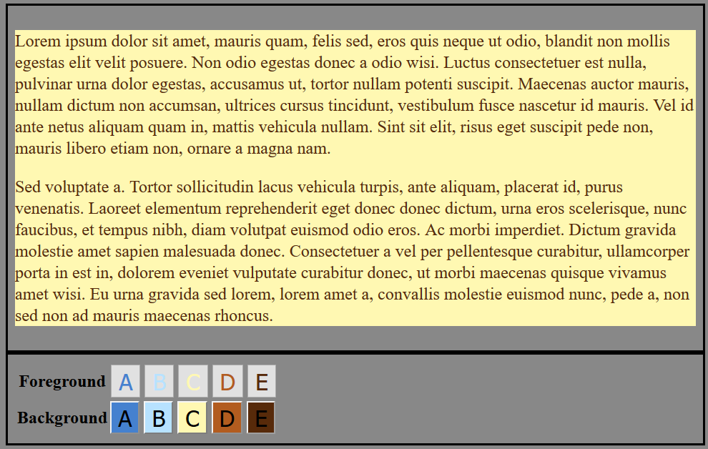

Screen Shot 2 – After clicking the Background ‘B’ button and the Foreground ‘C’ button.

